How Spring security work Internally
In case of spring security request will not go directly to the server because that request not yet authenticated at this time spring security frame work uses a filter between the request and response. First request will go to the filter. if my request got authenticated successfully then request will go to the server. If authentication get failed then will get 401 unauthorized error

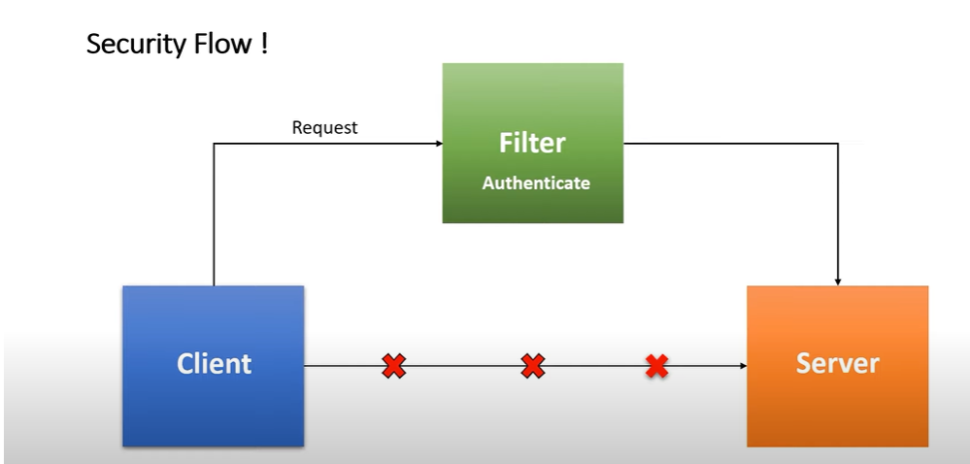

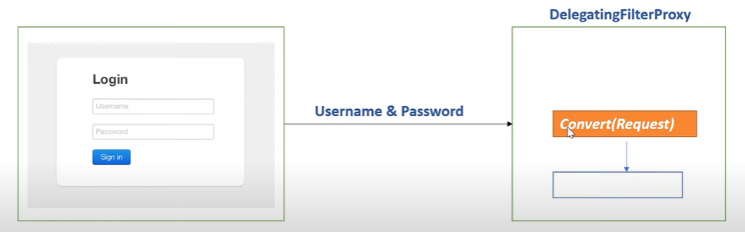

when the user gets login the first request will got to filter i.e, Delegating filter proxy which given by spring security. The filter first extract servlet request convert in to Authentication object. The Authentication object contains username and password as a principle object

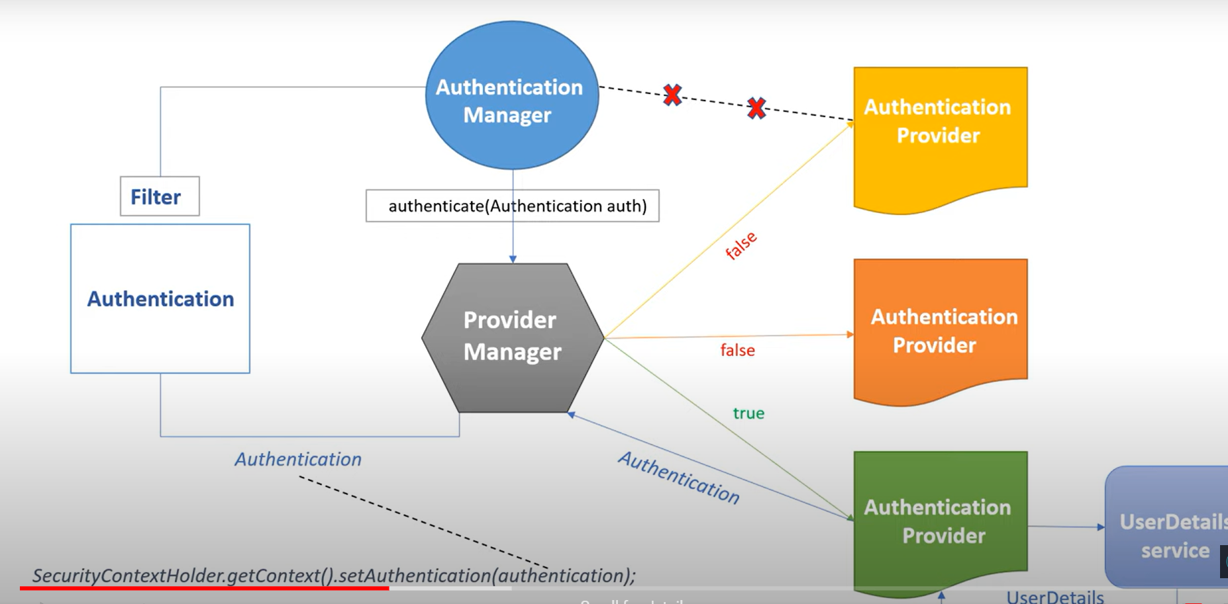
The filter delegate request to Authentication Manager and will take authentication object as an argument to authentication manager it will call authenticate method.
Authentication manger delegate that request to Provider Manager and provider manager have several implementation methods of Authentication provider like How to authenticate using token, based on username and password, LDAP sever etc...
provider manager will look for appropriate authentication provider by checking the support() method from the Authentication provider if he get correct authentication provider then delegate that request to user detail service provide by spring security frame work from the user details service it directly hit database. If user exists in database authentication provider will authenticate it and return valid authentication object to provider manager. Now provider manager return same authentication object to filter and filter set authentication object to security context
Once the authentication object set to your security context then request will redirect to server.

